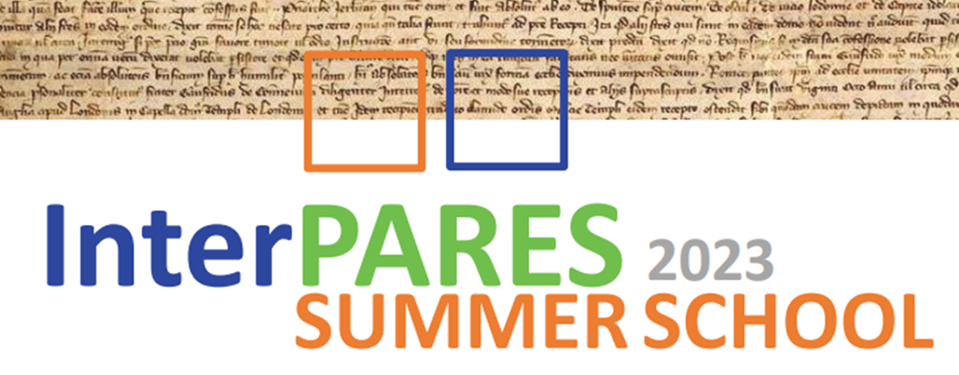

4
2026

June 22-26, 2026
San Benedetto del Tronto (Ascoli Piceno), Italy

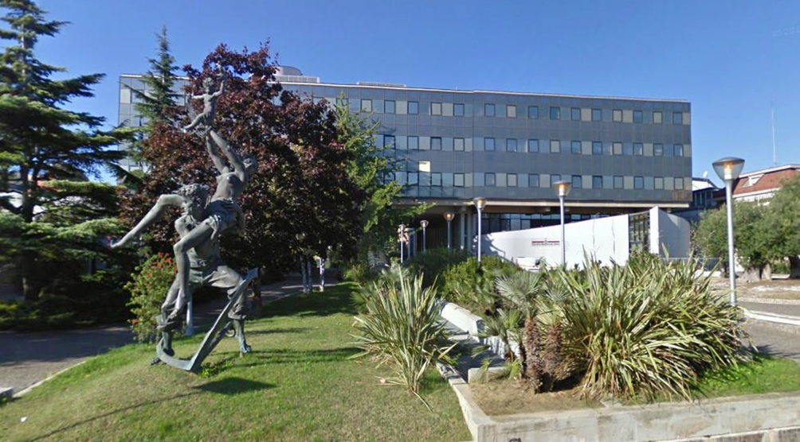
Palazzo comunale di San Benedetto del Tronto – Town Hall of San Benedetto del Tronto https://goo.gl/maps/VqC8HP4BHUQ4jPtz7

Overview
The InterPARES Summer School program is designed to present the most significant ﬁndings of 25 years of research about trustworthy digital records creation, maintenance, preservation, use, and access across technologies, discussing both theory and best practice for digital records and archives management. Professional archivists will come in contact with the latest developments in archival science and the use of artificial intelligence in archival science.
Day 1 – Monday, 22 June
8:30 Registration
9:15-10:30 Welcome and Introductions
Welcome from government officials and the School’s organisers; students’ introductions; logistic details.
10:30-11:00 Coffee Break
11:00-12:15 Luciana Duranti, Authentic Digital Records
InterPARES tested the traditional concept of record in the digital environment, determining the characteristics of digital records as well as their necessary Andrea suﬃcient attributes. This class will discuss the ﬁndings of InterPARES with respect to the nature of digital records, how to maintain their authenticity and how to ensure that it will be veriﬁable over time.
12:15-13:45 - Lunch
13:45-15:00 Hrvoje Stančić, Technological Authentication
The digital era brought new challenges to the archives. The underlying archival theory and concepts are the same for analogue and digital records. However, the technical manifestation of digital records, their variety, speed of creation, volume, and volatility require new computational approaches, especially regarding record authentication. Digital signatures bring another layer of complexity to the long-term preservation of digital records, because the certiﬁcates they rely upon expire much sooner than the records’ retention period. Blockchain and distributed ledger technologies (DLT) can support records’ integrity, conﬁrm their sequence, enhance non-repudiation, but also help preserve the validity of digital signatures. This class will present the TrustChain model, resulting from the InterPARES Trust project research, together with the use case of a system for authenticating analogue university diplomas by connection to the blockchain.
15:00-15:30 Break
15:30-16:45 Pierluigi Feliciati, Trusted and easy access to records and archives
This class will present and discuss the InterPARES main concepts and issues related to archival reference and access. It will focus on access as presented in the main archival conceptual models and standards, on the role of records managers and archivists in mediating between authentic records and users in digital environments, and on how the related activities could be successfully managed. One of the topics will be a user-centred approach in the phases of conception and development of reference and access services, considering the organization of user studies to conceive, build and maintain good archival digital services. Part of the class will be discussing and evaluating some archival access services to better focus on the notion of “quality” and the primary metrics for its evaluation.
Day 2 – Tuesday, 23 June
9:15-10:30 Corinne Rogers, Trustworthy Digital Preservation
What is required to preserve trustworthy digital records over time and through technological change? This is a question that InterPARES has addressed from the beginning. The ﬁrst two InterPARES projects formulated and elaborated the concept of the chain of preservation, providing a basis for judging the trustworthiness of records’ preservation. This class will examine the functional and data requirements for digital preservation as derived from the Chain of Preservation Model (COP), and, under the rubric of Preservation as a Service for Trust (PaaST), will outline a comprehensive model developed by the 4th phase of InterPARES (InterPARES Trust) for integrating what is required in digital preservation with technical approaches for meeting such requirements in the cloud.
10:30-11:00 Break
11:00-12:15 Erik Borglund, Records in the Cloud
Modern cloud service as we see it today was established by Amazon in 2002, when it was used as an internal service. In 2006, Amazon oﬀered the service outside the company. The cloud as a technology and the related service providers have been a challenge for records and archives professionals, and others. The focus of this class is on the ﬁndings of InterPARES Trust, “Records in the Cloud”, but it will also discuss the cloud technology challenges that one can encounter today.
12:15-13:45 Lunch
13:45-15:00 Joe Tennis, Records Metadata
InterPARES has established Benchmark and Baseline requirements for keeping and preserving authentic records in digital systems. These, along with the Chain of Preservation Model, have been used to create the InterPARES Authenticity Metadata (IPAM). This class will present these ﬁndings from InterPARES and discuss their relevance in the emerging technological environment.
15:00-15:30 Break
15:30-16:45 Scott Cameron, The Role of Paradata in Ensuring Trust in the Use of Artificial Intelligence (AI) Systems
Day 3 - Wednesday, 24 June
9:15-10:30 Hrvoje Stančić, Computer Vision and Digitized Images Collections
This class will focus on AI model training methodology, using a digitized archival collection of portraits from the late 19th and early 20th centuries as an example. The AI model will be explained in the context of developing archival AI tools designed to eliminate repetitive and time-consuming tasks. Challenges in image annotation will be discussed, along with the results of a comparative analysis of multiple image annotation solutions. Experiences in model training will be covered, comparing the use of a dedicated personal computer, Google Colab, and supercomputer approaches. A developed model, available online, will be showcased. Finally, the class will conclude by highlighting emerging trends in AI-assisted digitization and process optimization in archives.
10:30-11:00 Break
11:00-12:15 Jim Suderman, DarraHofman, Victoria Lemieux, Hrvoje Stancic, Interactive session
12:15-13:45 Lunch

13:45-16:45 Emanuele Frontoni, and Alessandro Cacciatore - half a day - workshop with a half hour break
This half-day, hands-on workshop introduces participants to agentic AI and its emerging role in archival practice, moving beyond single-prompt interactions with generative models toward autonomous agents capable of planning, reasoning, and executing multi-step tasks over archival materials. After a concise conceptual framing of what distinguishes an AI agent — perception, memory, tool use, and goal-directed action — from a conventional language model, the session focuses on agents built on Vision-Language Models (VLMs), which combine image understanding with natural-language reasoning and are therefore particularly well suited to the visual and textual heterogeneity of archival collections. Participants will explore how VLM-based agents can support core archival functions such as describing and classifying digitised documents, reading handwritten and printed text, extracting and structuring metadata, linking records, and assisting reference and access — while keeping the archivist firmly in control of appraisal, interpretation, and validation. Drawing on the experience of the PERGANet framework, including work on accessing medieval and historical sources with AI, the workshop pairs short demonstrations with guided exercises in which attendees configure and test simple agents on sample archival data. Participants are encouraged to bring a laptop in order to take part in the practical exercises; no prior programming experience is required.
Day 4 - Thursday, 25 June
9:15 – 10:30 Victoria Lemieux, Clio-X: Ethical Artificial Intelligence (AI) Compute On Demand for Archivists and Researchers
This class will present a demonstration of Clio-X a Web3 data space that oﬀers a novel decentralized and ethical AI-enabled reference and access solution for archives and researchers. Clio-X was developed because archival institutions have many archival documents of a sensitive or high-risk nature and growing researcher requests for access and analysis of these documents using AI. Clio-X addresses this demand by: (1) allowing archives to make archival datasets available to run a variety of AI-enabled computations on demand (e.g., exploratory data analysis, clustering, topic modelling, sentiment analysis, handwriting recognition and sound recording transcription) and (2) enabling AI-enabled access and compute in such a way that the data never leaves the custody and control of the archives but is still able to return aggregated output results to researchers in the form of statistics, conversational search output or data visualizations. Datasets are identified by unique identifiers called DIDs, which are like URIs but can also be used to cryptographically verify the identity and integrity of a dataset.
10:30-11:00 Break
11:00-12:15 Tracey P. Lauriault, Data as artifacts and as records
This class will present the relationship between metrology and data, and discuss how to consider data beyond normalized technological understandings. Examples will be drawn from the InterPARES 2 General Studies about the concepts of reliability, accuracy and authenticity in the sciences, and from the InterPARES Trust AI case studies about digital twins and smart grids. The class will end with a discussion of the relationship between data and records.
12:15-13:45 Lunch
13:45-15:00 Jim Suderman, Privacy and Ethics in the Era of Artificial Intelligence (AI)
This class will peek behind the curtain of AI tools and techniques and their potential application in the archival ﬁeld. These tools provide incredible possibilities to enhance appraisal, description and access to archival holdings, but their strengths and limitations must be understood in terms of how and why they were developed, so as to mitigate the risk of undermining the fundamental values that drive archival work. Similarly, responsibly providing records for transformation into data to train AI models requires archivists to consider how this might aﬀect the individuals identiﬁed in such records. This session will reﬂect on ethical principles from both the archival and AI communities and share practical experience gained within an InterPARES Trust AI study, especially with regard to privacy protection.
15:00-15:30 Break
15:30-16:45 Darra Hoffman, Laws and Regulations Concerning Artificial Intelligence (AI)
With the recent passage of the Artificial Intelligence (AI) Act, the European Union has established a regulatory framework governing the development and use of AI within the EU. A primary goal of the AI Act is to ensure that AI systems are used in ways aligned with EU values, including transparency, accountability, privacy and human rights. While the AI Act does not expressly address the use of AI in the records and archival management context, key aspects of the Act have applicability to how records are described, classified, managed, retained, and accessed by the public. This class will discuss examples of how the AI Act may influence the use of AI in performing records and archival management functions in the future. It will also look at how the AI Act intersects with the EU’s General Data Protection Regulation on matters governing sensitive personal information in records repositories. Finally, the EU’s experience in enacting AI regulations will be compared and contrasted with the AI legal and regulatory environment in the United States.

Day 5 - Friday, 26 June - SYMPOSIUM
DRAFT PROGRAM

09:00 Welcome from hosts
Luciana Duranti, UBC
Welcome
09:30 Muhammad Abdul Mageed, University of British Columbia
Socially embedded AI – The NLP Lab at UBC; UNESCO Radio Archives
10:15 Darra Hoffman, San Jose State University
AI and Access To Public Records
10:45 Tracey Lauriault, Carleton University
Digital Twins: Preserving the parts and not the whole
11:15 Victoria Lemieux, University of British Columbia
Clio X
12:00 Emanuele Frontoni, University of Macerata
Perganet: Accessing the Middle Ages with AI
13:00 Questions
13:30 Break for lunch
14:45 Scott Cameron, Bank of Canada
Paradata for AI Accountability
15:15 Hrvoje Stančić, University of Zagreb
Blockchain and AI: A Perfect Match
15:45 Luciana Duranti
Educating for the future
16:15 Questions & Wrap Up
16:45 Adjourn

Faculty bios
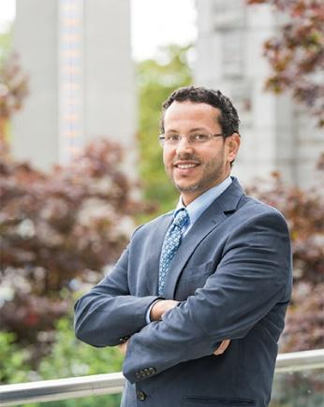 | Muhammad Abdul-Mageed – University of British Columbia, Canada  Dr. Muhammad Abdul-Mageed is a Canada Research Chair in Natural Language Processing and Machine Learning, and Associate Professor in the School of Information and Department of Linguistics (Joint Appointment), and Computer Science (Associate Member), at The University of British Columbia. His research focuses on deep representation learning and natural language socio-pragmatics, with a goal to innovate more equitable, efficient, and ‘social’ machines for improved human health, safer social networking, and reduced information overload.
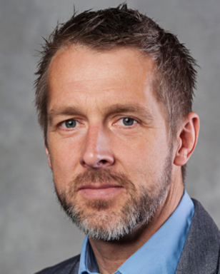 | Erik Borglund – Mid-Sweden University, Sweden  Dr. Erik Borglund is a Professor in archives and information science at Mid Sweden University, campus Sundsvall. Erik has been involved in InterPARES since 2012, as well as in the Digital Records Forensic Project (UBC). Erik’s main research focus is on current recordkeeping in the crisis management domain.

 | Scott Cameron, Bank of Canada, Canada  Scott Cameron is an Archivist and Librarian. He has contributed to the InterPARES research group on paradata since 2022, and presently works in research data management at the Bank of Canada. Responsibility for the views expressed should not be attributed to his employer.

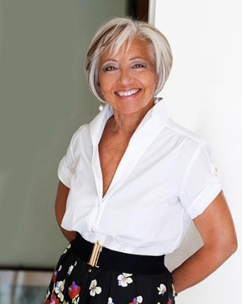 | Luciana Duranti – University of British Columbia, Canada  InterPARES Trust AI Principal Investigator and Co-Director  Dr. Luciana Duranti is since 1987 a Professor of archival theory, diplomatics, and digital records in the master’s and doctoral archival programs of the School of Information of the University of British Columbia (UBC), in Vancouver, Canada, and, since 2011, Affiliate Professor at the University of Washington at Seattle, United States. Since 1998, she is the Principal Investigator of the InterPARES research project. She has published extensively on archival and diplomatics theory and on the use of their concepts for understanding the products of new technologies. Since 2015, she is the Chair of the Canadian Government Standards Board committee for Electronic Records as Documentary Evidence.
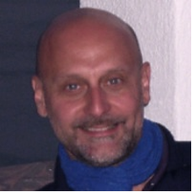 | Pierluigi Feliciati – University of Macerata, Italy  Dr. Feliciati was an Archivist in the Italian National Archives from 1986 to 2007. He coordinated the Information Systems of the Italian State Archives network and their ﬁrst Web portal. He is Associate Professor of Archival and Information Science at the University of Macerata, where is the pro-rector for digital archives. In 2019 he was a visiting Professor at the Information School of the University of British Columbia (Canada). He leads the UniMC research group of InterPARES Trust AI. He is the co-editor of the JLIS.it journal.
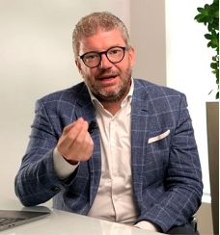 | Emanuele Frontoni – University of Macerata, Italy  Dr. Emanuele Frontoni is Full Professor of computer science at the University of Macerata and the Co-Director of the VRAI Vision Robotics & Artiﬁcial Intelligence Lab. His research interests include computer vision and artiﬁcial intelligence, with applications in robotics, video analysis, human behavior analysis, extended reality and digital humanities. He is the author of over 250 international articles and collaborates with numerous national and international companies in technology transfer and innovation activities. He is also involved in several projects in the ﬁelds of AI, Deep Learning, data interoperability, cloud-based technologies, and big multimedia data analysis, extended reality and digital humanities.

 | Darra Hofman – San Jose State University, United States  Dr. Darra Hofman received their Ph.D. in library, archival, and information science from The University of British Columbia in 2020. They completed her M.L.I.S. from the University of Kentucky and her J.D. and B.A. (honors) from Arizona State University. Their research examining the intersection of archives, technology, and law has been published in a number of journals, conference proceedings, and edited collections. In particular, they are interested in privacy, blockchain technologies, and health records.

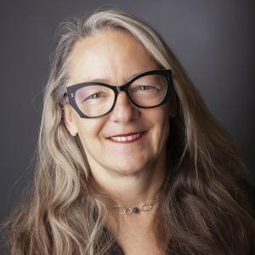 | Tracey P. Lauriault – Carleton University, Canada  Dr Tracey P. Lauriault is Associate Professor, Critical Media and Big Data, School of Journalism and Communications, also with Digital Humanities, and the Institute for Data Science at Carleton University in Ottawa, Canada. She is one of the founders of critical data studies; open data in Canada, and Open Smart Cities. Her research involves data preservation, digital twins, smart cities, data brokers and indigenous data governance. She mobilizes her research into data and technology policy and aims to make data and technological systems more just, inclusive, equitable and sustainable.
 | Victoria Lemieux – University of British Columbia, Canada  Dr. Victoria Lemieux is an experienced and multidimensional academic, technology leader, and innovator. She is founder and co-lead of Blockchain@UBC, the University of British Columbia’s multidisciplinary blockchain research cluster. Her academic research focuses on risk to the availability of trustworthy records and how these risks impact upon transparency, financial stability, public accountability, and human rights.
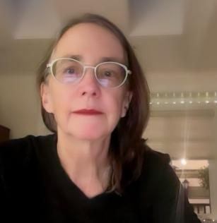 | Corinne Rogers - University of British Columbia, Canada  Dr. Corinne Rogers is the InterPARES Project Coordinator (2012-present). From 2012-2024 she was an adjunct professor in the Information School at the University of British Columbia (diplomatics, digital records forensics, and digital preservation). From 2018-2021 she was a Systems Archivist at Artefactual Systems, lead developers and organizational home to open source projects for digital preservation, AccessToMemory (AtoM) and Archivematica.

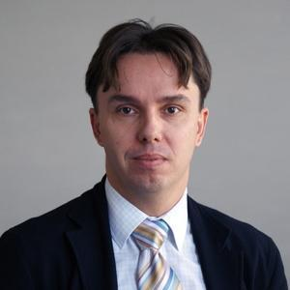 | Hrvoje Stančić – University of Zagreb, Croatia  Dr. Hrvoje Stančić is Vice-dean for business, and Full Professor at the Faculty of Humanities and Social Sciences, University of Zagreb, where he teaches in the Department of Information and Communication Sciences. He has been Chair of archival and documentation sciences at the same Department since 2008. In the context of the 4th InterPARES project (2013-2019) he was Director of the European research team and led a blockchain-related research study. At the Croatian Standards Institute, he is President of the mirror technical committee for development of ISO/TC 307 Blockchain and Distributed Ledger Technologies standard
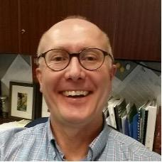 | Jim Suderman - City of Toronto, Canada  Jim Suderman recently retired from the position of Director of Information Access at the City of Toronto, where he oversaw the operations of the City's records management, archives, and information and privacy protection programs. Prior to that he was a Senior Archivist and the Coordinator of the Electronic Records Program at the Archives of Ontario. He has been a researcher in InterPARES 2 and 4, and is currently a co-investigator in InterPARES Trust AI.

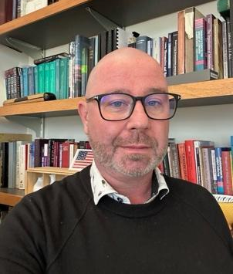 | Joseph T. Tennis - University of Washington, USA  Dr. Joseph Tennis is a Professor of Information Science, Adjunct Professor in Linguistics, and a member of the Textual Studies, Computational Linguistics, and Museology faculty advisory groups at the University of Washington. He was Chair of the Governing Board for the Dublin Core Metadata Initiative, where he also serves on the Usage Board since 2006. His research is on classiﬁcation theory, information provenance, metadata versioning, ethics of knowledge organization work, descriptive informatics, and authenticity. He teaches classiﬁcation, metadata, and intellectual foundations of information science.

