|  |  |
| --- | --- |
| **Title** | Using Distant Reading to Enhance Archival Access Whilst Protecting Privacy |
| **Working group code** | RA06 |
| **Study title** | Privacy in Digital Records Containing Personally Identifiable Information (PII)-An Exploration of Current Status and the potential of AI Tools and Techniques |
| **Status** | Final |
| **Version** | 2.0 |
| **Writers** | Victoria Lemieux, Cheuk Kit (Philip) Chung, Chris Zhou, Zehua Wang |
| **Date** | June 8, 2024 |

**Using** **Distant Reading to Enhance Archival Access Whilst Protecting Privacy**

**Keywords**:

distant reading, privacy-enhancing technology, visualization, federated machine learning

**Introduction**

Globally, critics are sounding the alarm about the way that AI, particularly large language models, are disclosing personal information from information gathered from a wide range of sources, including public archives (see, e.g., Das, Lee, and Fortizzi, 2023). As an increasing number of public archival institutions are digitizing their materials and putting them online, or acquiring contemporary born digital records, the risk of exposing individuals’ personal information when providing public access to archives has risen exponentially. Personal data leaks from AI can take many forms, from accidental disclosure by archival staff to data gained by deliberate attempts to by-pass privacy and security controls in institutions often ill equipped to defend against such attacks.

As archivists have a mission both to provide access to records and protect personal information, they now must comply with a growing body of laws, such as exemption provisions found in freedom of information laws or provisions of data protection legislation, that have arisen as a response to widening concerns about privacy and confidentiality in the digital age. Interpretation and application of these laws adds complexity to the archivists’ task of providing access to archival holdings.

Since making records available in a legally compliant manner remains challenging for archivists, it is worth experimenting with an emerging class of technologies known as Privacy Enhancing Technologies (Lemieux and Werner, 2024). These technologies – which include homomorphic encryption; Trusted Execution Environments; Secure Multiparty Computation; Differential Privacy; Personal Data Stores; Privacy Preserving Machine Learning; and Synthetic Data (Royal Society, 2019) – allow for AI-enabled analysis of archival documents without requiring that researchers gain direct access to the documents.

One novel approach that could work is to combine a technique increasingly used by researchers in the Digital Humanities called Distant Reading (Moretti, 2013) with Decentralized Privacy Preserving Federated Machine Learning to protect personal information from exposure.

Distant reading is a research approach in literary criticism and historical studies. This method, advocated by Franco Moretti (2013), contrasts with traditional close reading, which focuses on detailed analysis of individual texts. Moretti suggested a different approach to comprehending the vast volume of literary output, like mass-produced novels of 19th-century Britain, by analyzing the collective system of literature rather than its individual parts. Distant reading uses computational methods to analyze large corpora of texts, revealing broader patterns and trends across a significant body of work, allowing a comprehensive analysis of sources over a long duration of time and space. Typically, the output of such analyses is a visualization that represents broad patterns that can be gleaned from archival documents, such as the communication patterns between geolocations, public sentiment over time, or topics or themes represented in a corpus of archival text. Using Distant Reading enables researchers to learn from large archival corpora without having to inspect and analyze each individual document, which, in turn, relieves archivists of the burden of undertaking sensitivity reviews before providing public access to their holdings. In this paper, we provide an overview of distant reading, particularly in textual analysis and its corresponding visualization tool. Meanwhile, we discuss the limitations of distant reading, such as the risk of leaking of PII. Then, in the final section, we provide suggestions involving the use of privacy-enhancing technology, specifically federated machine-learning- to enhance distant reading to prevent leakage of PII.

**Overview of Distant Reading**

***Methodology****:*

In this research, we used the snowball search technique. According to the University of Cambridge definition (n.d.), the snowball search method “involves screening all the articles that cite your included papers (the articles which meet your inclusion criteria after screening).” We gathered all articles from Google Scholar that referenced Ian Milligan's article, *Mining the 'Internet Graveyard': rethinking the historians' toolkit* (2013). This article discusses how historians must adapt their research methods to the growing volume of digital-born historical sources. In the context of historical research, Ian Milligan’s work, written in 2013, was among the first publications demonstrating the application of Moretti’s distant reading technique to historical research. Since then, many multi-disciplinary scholars have cited Milligan’s methodologies to study historical ‘big data’.

Following the harvesting of suitable articles, we closely read each article and analyzed elements such as research type, distant reading technique, data sources, visualization types, algorithm types, and privacy concerns. We then categorized the distant reading techniques based on their type of analysis, visualization, and algorithm. Note that this research only includes textual analysis and does not cover other forms of analysis, such as image, audio, video, or color analysis.

***Findings****:*

In Milligan's "Mining the Internet Graveyard", about a third of the 41 referenced articles overview distant reading and historical big data. However, only approximately a quarter directly address the topic through presentation of methodologies and case studies. Notably, a scant few discuss the ethical issues associated with distant reading. Some articles are written in French and Russian, making it challenging to interpret their content without translation.  We therefore focused on English language articles.

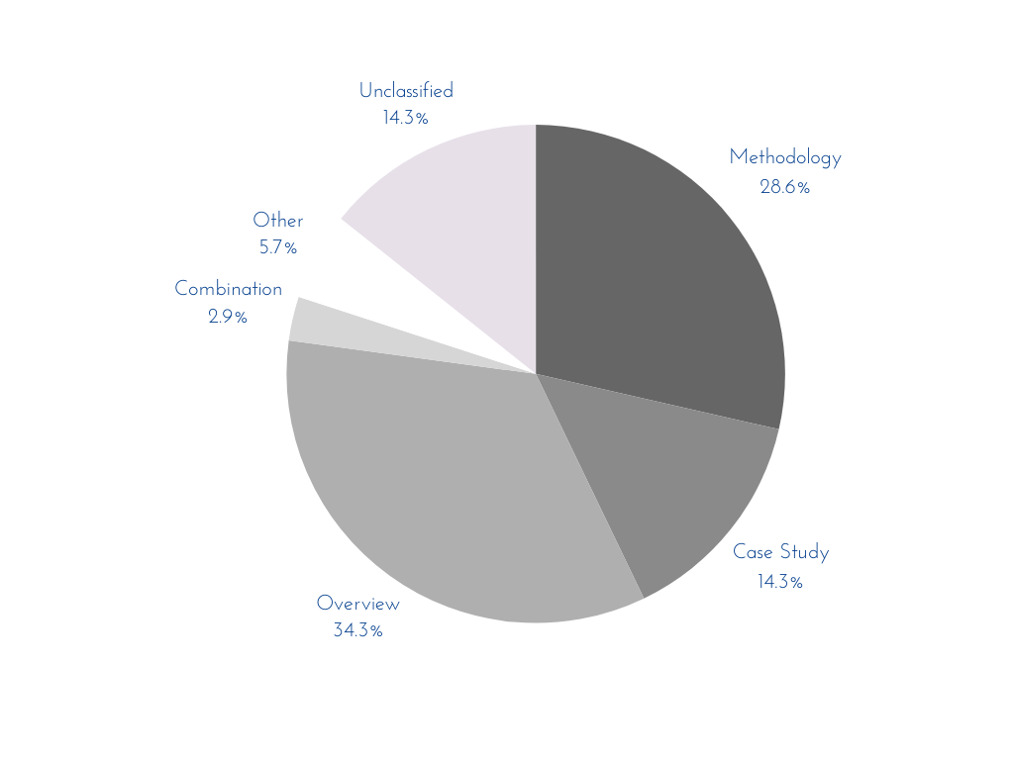

Fig. 1: The distribution of the literature citing Milligan’s *Mining the Internet Graveyard*

**What is Textual Analysis and the Importance of Visualization?**

Distant reading frequently uses both textual analysis and visualization. Textual analysis is a method used to extract meaningful data from text through processes such as dissemination, measurement, and interpretation. It helps researchers understand cultural, social, or political contexts of a certain text. Visualization plays a pivotal role in textual analysis as it provides an intuitive and comprehensive understanding of the data. It allows researchers to uncover patterns, trends, and insights that might otherwise be challenging to discern from raw data. Visualizations such as charts, graphs, and diagrams can simplify complex data sets, making them more accessible and easier to understand. They help in communicating findings effectively, making data-driven decisions, and predicting future trends.

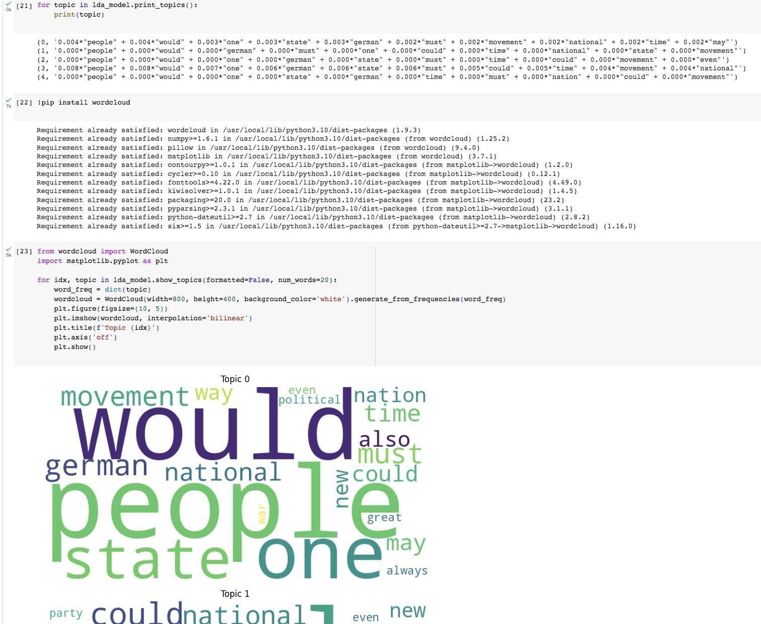

*Fig.: The Textual Analysis and Visualization*

**Types of Textual Analysis**

1. **Frequency**

Frequency analysis is a fundamental technique in text analysis that involves counting the frequency of specific words or features in a text or group of texts. This method aids in identifying common elements and themes. By tracking the frequency of word occurrence, researchers can identify major themes, shifts in sentiment, or the author's habits. Frequency analysis is a versatile tool in text comprehension, enabling the discovery of key ideas and tracking language evolution over time. It offers a straightforward way to gain insights into the structure and content of text data, simplifying understanding and exploration in text analysis. (Graham et al., 2016, p.73-78)

The data for frequency analysis usually comes from large corpora of texts, which could be traditional or digital records. Visualization techniques used in this method include word clouds, line graphs (for trend analysis), bar charts, and plots. As for the computing aspect, techniques such as Natural Language Processing and Word Tokenization are typically employed.

**Visualization of Frequency - Word Cloud**

A Word Cloud is a visualization technique used in text analysis where words from a text or corpus are displayed in a cluster. Each word’s size in the cloud shows its frequency or importance within the text. Words appearing more frequently are displayed as larger and more centrally, providing a quick way to perceive the most prominent terms. Word clouds are useful for data exploration, understanding key themes or patterns, and analyzing sentiments in a text dataset. (Milligan, 2013, p.43-44)

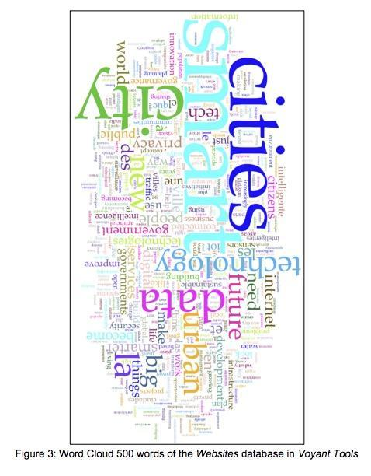

As an example, Therrien (2021) used a word cloud to visualize the most frequent terms in the *Websites* database, which contains information on smart cities. The word cloud function positions words based on their frequency, with the most frequent terms centrally located and in the largest size. This method identified "smart cities" as the most commonly used term among the top 500 words in the database. The calculations were performed using Voyant Tools, a web-based platform that uses Jason Davies' D3-based Word Cloud library (Therrien, 2021, p. 276).

**Visualization of Frequency - Dispersion Plotting**

Dispersion plotting is a visualization technique used in frequency analysis. It shows the occurrences of a word in a text or corpus over time. Each dot on the plot represents a word occurrence, providing a visual representation of word distribution. It can reveal patterns and trends in the use of specific words, thereby providing valuable insights into the text. (Fasang & Liao, 2014)

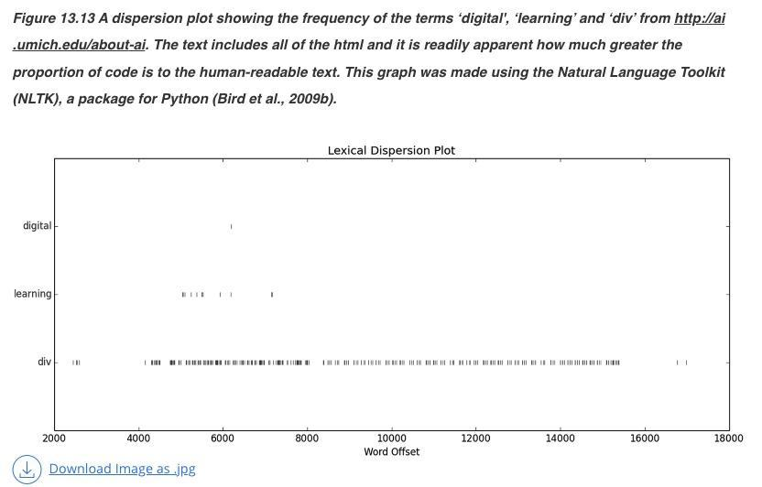

Joque (2018) demonstrates a dispersion plot visualization to show lexical dispersion of words in a corpus. This tool is used to illustrate the occurrences of the terms of “digital”, “learning” and “div” throughout the corpus from the dataset of<http://ai.umich.edu/about-ai>, marking how many words relative to the beginning of the corpus each term appears. This analysis was carried out using the Natural Language Toolkit (NLTK) and the results were visualized using R. (Joque, 2018, p.25)

**2. Graph Analysis**

Network analysis is a method used in distant reading. It applies network theory to analyze vast text collections, helping to understand the relationships within a corpus, such as characters in novels or concepts in articles. This method uncovers the structure, dynamics, and patterns that are not visible through traditional close reading (Graham et al., 2016, p.195-198).

Network analysis is often used in social network analysis, which uses networks and graph theory to examine social structures. In this context, nodes represent individual entities or actors within the network, while ties, edges, or links symbolize the interactions or relationships between these entities. Network density is usually calculated as the proportion between the actual number of links and the highest possible number of links in the network.

The data used in network analysis can come from various sources, including web archives, hyperlinks, traditional records, and literature. The analysis outcome can be visualized in various ways, such as graphs, plots, heatmaps, and network diagrams. Computing methodologies used in network analysis include PageRank (Graham et al., 2016, p.219-220), Bellman-Ford (Parimala et al., 2021), and H-index (Lu et al., 2016).

**Visualization of Network Analysis - Network Graph**

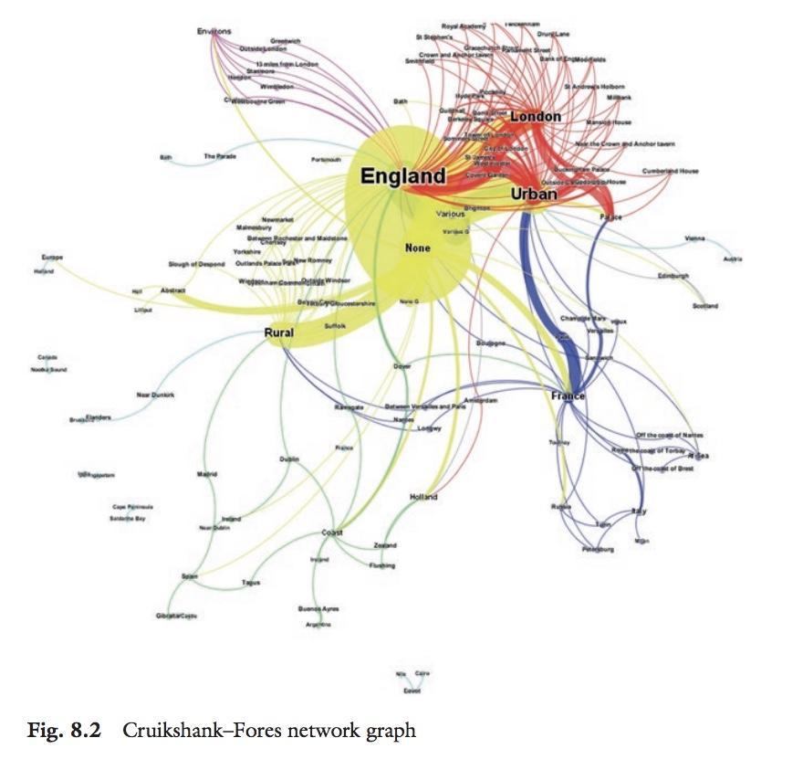

Baker (2017) primarily employs historical satirical prints, particularly those by Isaac Cruikshank, as the main data sources. Network diagrams, a type of graph, are used to depict connections between a set of entities. Each entity, or node, is connected to others through links, or edges. The purpose of these diagrams is to visualize the relationships between different locations illustrated in the satirical prints. The graph reveals that the business of satirical prints was predominantly from London and urban areas to other places, such as France (p.135). The visualizations are created using the Force Atlas network layout algorithm Fruchterman & Reingold (p.173).

**Heatmaps**

A heatmap visualization is a two-dimensional display where data values are represented by colors. This type of visualization provides a quick visual summary across two axes, enabling users to easily identify significant or relevant data points. In network analysis, a heatmap can represent relationships between nodes or variables, indicating stronger relationships with warmer colors and weaker ones with cooler colors. (Gu, 2022, p.1-2)

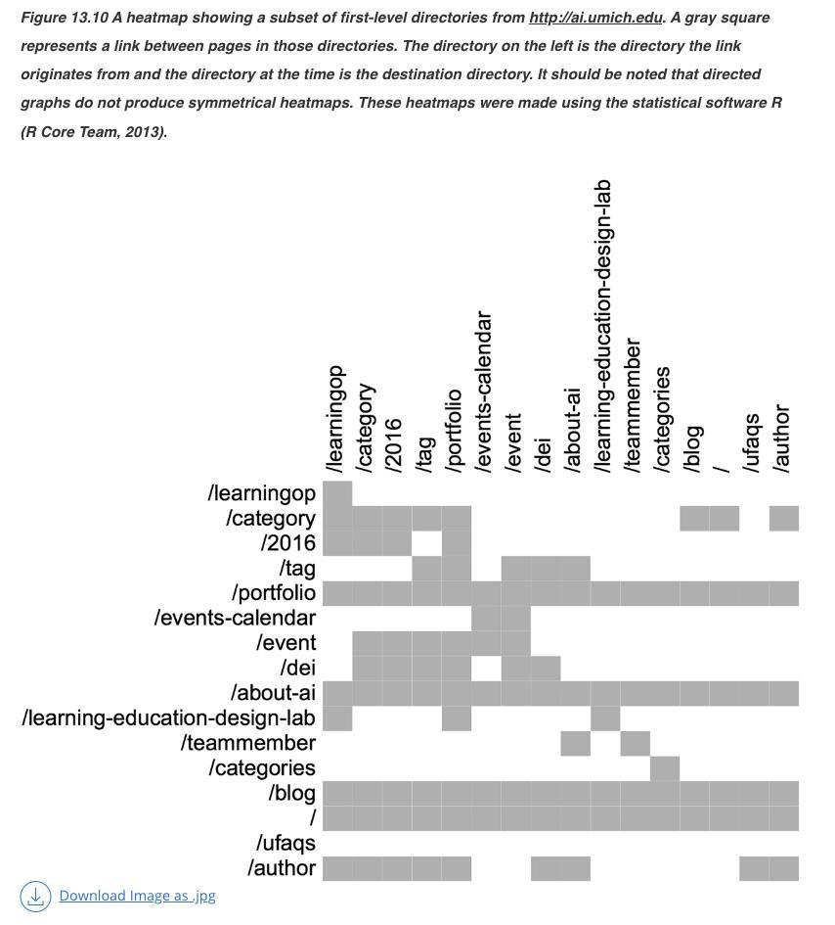

Joque (2018) presents various visualization research studies by different scholars. One such study focuses on heatmap visualization, using a subset of first-level directories from<http://ai.umich.edu> as data. Heatmaps are two-dimensional displays where data values are represented by colors. This simple heatmap provides a quick visual summary across two axes, enabling users to identify significant or relevant data points easily. In this heatmap, a link between pages in the directories is represented, with the color gray indicating a relationship between the x and y-axis. Although the analysis methodology was not specified in Joque’s paper, the visualization was created using R software. (Joque, 2018, p.19-22)

**Collocate Graph**

A collocate graph visualizes relationships between terms that frequently occur together within a text corpus. It offers a graphical representation of term associations, providing insights into key themes and concepts and their interconnections. This visual tool aids in understanding complex textual data (Alhudithi, 2021, p.43-50).

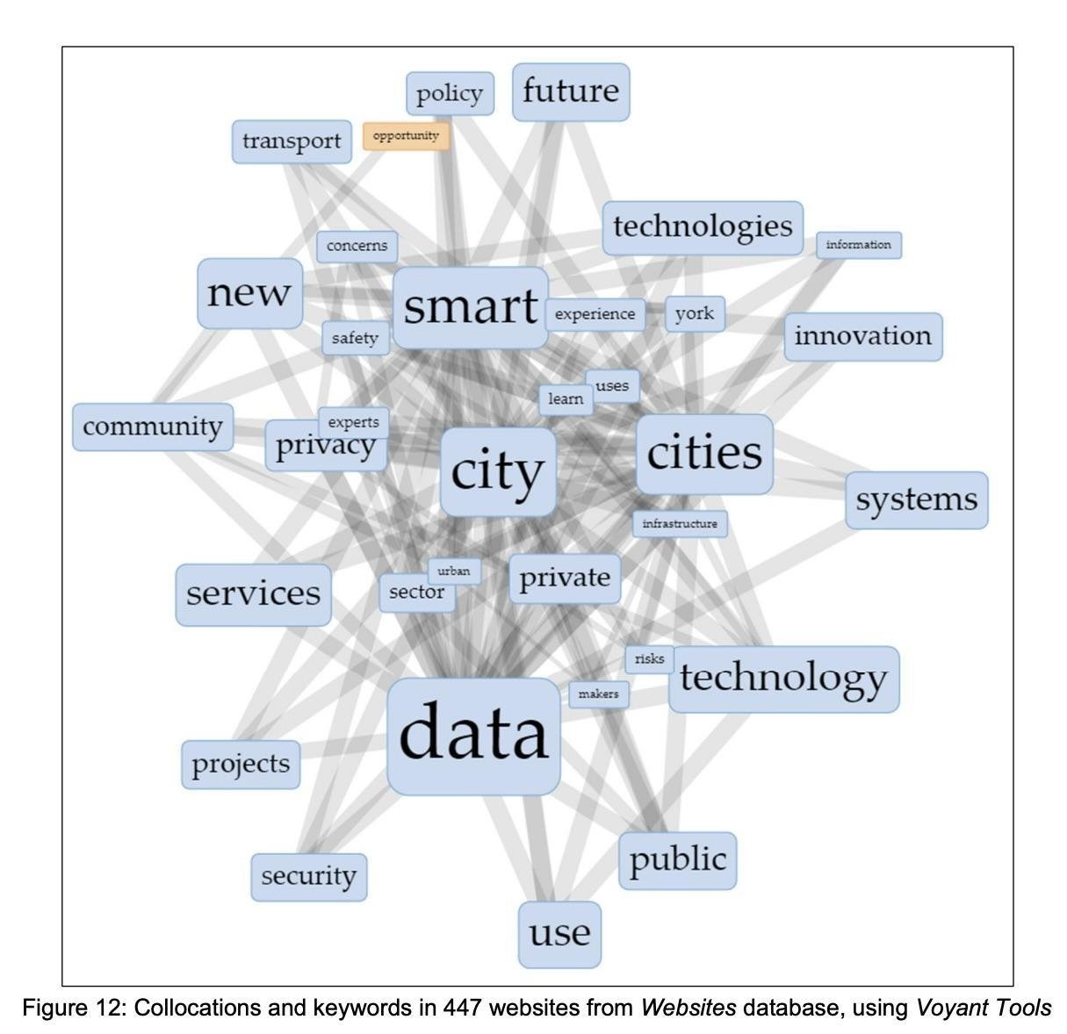

Therrien (2021) uses the collocate graph of Voyant Tool to visualize a large corpus of text (116,408 words) in 447 websites from the *Websites* database. The data for textual analysis encompasses a wide range of topics related to smart cities. The graph displays keywords in blue that are linked to orange collocates. It reveals that eight terms frequently appear in the same network of terms, which helps better understand the topics of the research articles. The algorithm of Voyant Tool’s collocate graph has not been mentioned in its website (Therrien, p.284).

**Hyperlink Network Analysis**

Hyperlink network analysis is a method that utilizes computational tools to scrutinize the structure and content of hyperlinked documents, such as websites. It involves the examination of vast volumes of text, and the analysis of data pertaining to the links between these documents. This process can yield insights into the popularity, influence, and interrelationships of the documents being studied (Park, 2003, p.49-52).

This method is utilized by researchers for a variety of purposes. These include the study of patterns in the dissemination of information on the internet, tracking the spread of ideas across online communities, and exploring the dynamics of online networks. Through this analysis, researchers can gain a more profound understanding of the processes of information creation, sharing, and consumption in digital settings.

The data used in hyperlink network analysis typically comes from web archives and metadata. The outcomes of the analysis can be visualized in various ways such as network graphs, heatmaps, treemaps, and time-series plots. As for the computational methodologies employed in this analysis, they include the use of web crawlers and the PageRank algorithm for discovery of hyperlilnks. .

**Hyperlink Network Analysis Visualization - Time-series Plotting**

Time-series plotting in hyperlink analysis visualizes the strength of hyperlinked connections over time. It can depict the evolution of linkages between websites or digital documents, providing valuable insights into the dynamics of online networks and the spread of information across the digital landscape.

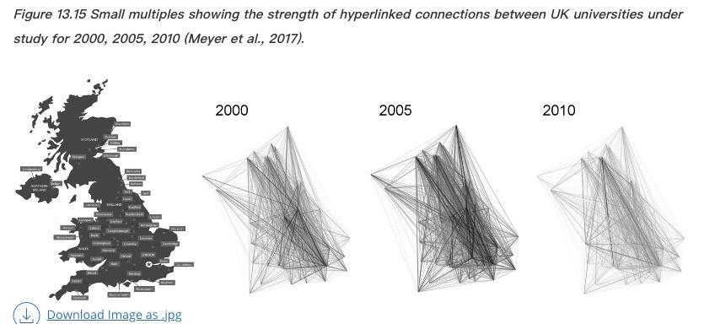

Joque (2018) demonstrates the time-series plotting of the hyperlink network analysis. The data used in this study was web data from UK universities. The primary visualization technique used was a time-series plot, also known as a time plot. This type of graph displays data points collected over a sequence of time. In a time-series plot, the x-axis represents time, and the y-axis represents the variable being measured. The purpose of this visualization was to depict the strength of hyperlinked connections between universities in the UK over time. The aim was to show that the connection of UK universities increased from 2000 to 2005 but declined in 2010. The specific computational methods used for this analysis were not mentioned (Joque, 2018, p.29)

**3. Scatter Plotting**

Scatter plotting is a technique for analyzing the relationship or pattern between two different variables. In a scatter plot, each data point represents one observation. One variable is represented on the x-axis and the other on the y-axis. Scatter plots utilize dots to exhibit values for two distinct numerical variables. The placement of each dot on the x and y axes denotes the values for a specific data point. Such plots are efficient means to analyze correlations between variables. (Graham et al., 2016, p.167-172)

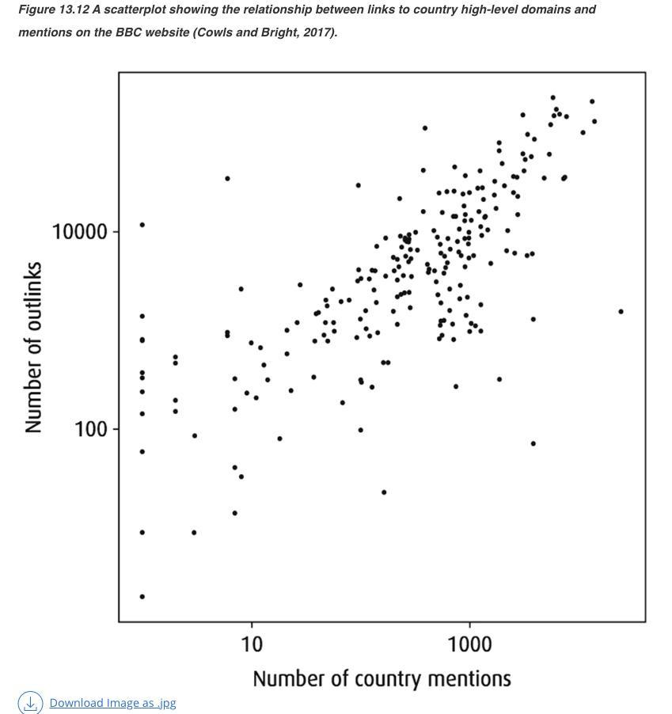

Joque (2018) uses scatter plotting to reveal information about the BBC Website along. In this case, the scatter plot is used to illustrate the relationship between links to country high-level domains and mentions, which appears to follow a linear regression pattern. However, the specific computing methods used for the analysis and visualization are not mentioned in the study (Joque, 2018, p.22-24).

**4. Topic Modeling**

Topic modeling is a technique that aims to discover hidden topics within a set of documents. The goal is to uncover the underlying themes or subjects in a text corpus, without the need for previous annotations or labels. This method is particularly useful for navigating through large text collections and gaining meaningful insights.

The data used in topic modeling can come from various sources such as web archives, traditional records, literature, and metadata. The outcomes of topic modeling can be visualized in several ways, including graphs, plots, heatmaps, and network diagrams.

When it comes to computing methodologies, K-means modeling is commonly used in topic modeling. Through this method, it is possible to efficiently navigate and understand large volumes of text (Graham et al., 2016, p.113-119).

**Topic Modeling Visualization - Histogram**

In topic modeling, histogram visualization helps illustrate the frequency distribution of variables such as specific words or themes across a corpus. It uses rectangular bars, with the height of each bar corresponding to the frequency of a variable, thus showing how often a particular element appears within the dataset.

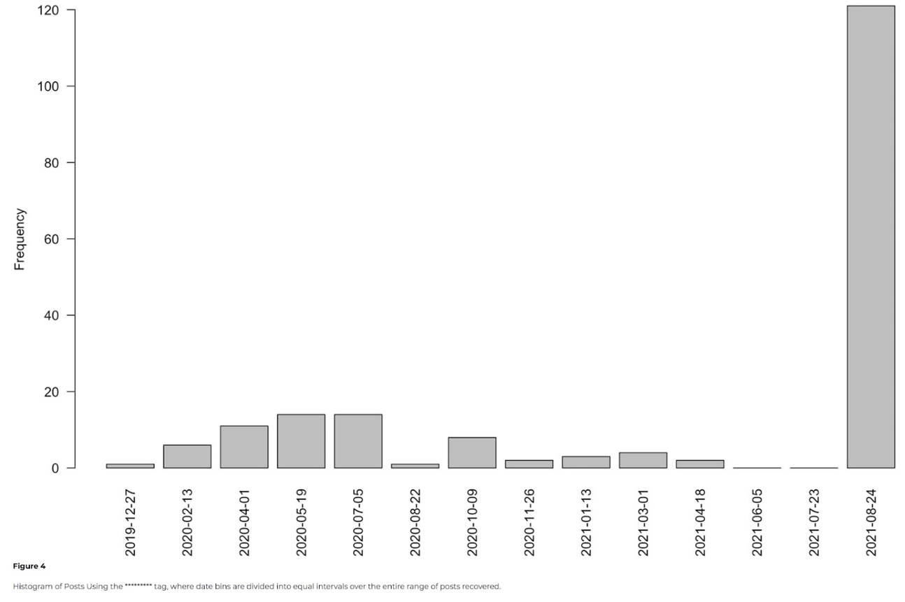

Graham et al. (2022) used histograms in their study. The data for this study was sourced from TikTok, with a focus on videos and comments related to the trade in human remains. The study utilized a histogram, a type of graph that represents the frequency of numerical data through rectangular bars. The height of each rectangle, along the vertical axis, corresponds to the frequency distribution of a variable, essentially showing how often that variable appears.

The histogram in this study was used to present the distribution of posts on TikTok that used a specific tag. Date bins, divided into equal intervals, spanned the entire range of posts recovered. This was part of the study's methodology to analyze the surge on TikTok in usage of certain hashtags related to the trade of human remains. By offering a visual representation of the frequency and distribution of posts over time, the histogram helped understand the temporal dynamics and public engagement with the topic on TikTok. Specifically, it shed light on how a user or a topic gains prominence on the platform over a given period.

However, the study did not mention the specific computing techniques used in the analysis and visualization process(Graham et al., p.202).

**Topic Modeling Visualization - Bar Chart**

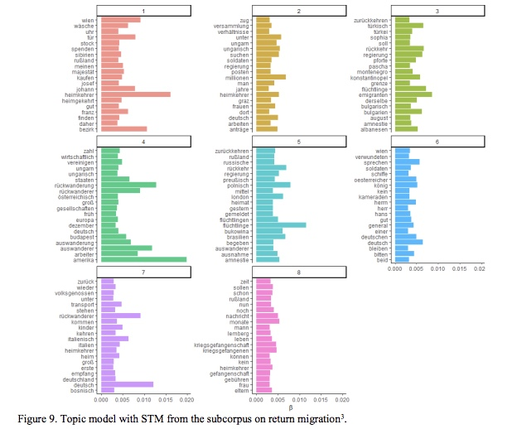

Pfanzelter et al. (2021, p.17-18) use topic modeling to analyze digitized historical newspapers. The goal is to uncover common themes and narratives within large datasets of archival content, drawn from a corpus of 472 articles on return migration issues from 1864 to 1944. The bar chart represents topics as clusters of co-occurring words, providing insight into the main themes and discussions within these articles. This method aids in identifying and tracking the evolution of public discourse over time, unearthing insights into historical narratives not immediately evident from the raw data.

The research uses advanced data analysis techniques, such as Structural Topic Modeling (STM), to handle the computational challenges of large textual datasets. The findings of the topic modeling are represented through visualizations created with Software R. These visual tools help researchers understand complex data by showing how topics distribute over time and across different newspaper segments. This deeper interpretation of data contributes to a nuanced understanding of past public discourses reflected in historical newspapers.

**4. Sentiment Analysis**

Sentiment analysis is a method that uses computation to identify the emotional tone behind words. This technique is employed to interpret sentiments, opinions, or attitudes that are expressed in texts. It has proven particularly useful in scrutinizing social media posts, customer reviews, survey responses, and other forms of text data where emotions and opinions are often revealed.

The data used in sentiment analysis can come from various sources. These include internet archives, traditional records, literature, and social media posts, among others. The technique offers various visualization methods, with heatmaps and topic distribution charts being among the most commonly used.

In terms of computing, techniques such as Latent Dirichlet Allocation (LDA) and Non-negative Matrix Factorization (NMF) are frequently employed in sentiment analysis. These methodologies help in the effective analysis and interpretation of sentiment data.

**Sentiment Analysis Visualization - Bar Chart**

Sentiment analysis visualization using a bar chart helps to visually represent the sentiments expressed in a textual dataset. It provides an understanding of the different emotions or opinions spread across the text by plotting them on a bar chart, where each bar corresponds to a specific sentiment, and its height illustrates the frequency or intensity of that sentiment. This method is useful for analyzing customer reviews, social media posts, and other text data where sentiment analysis is pivotal.

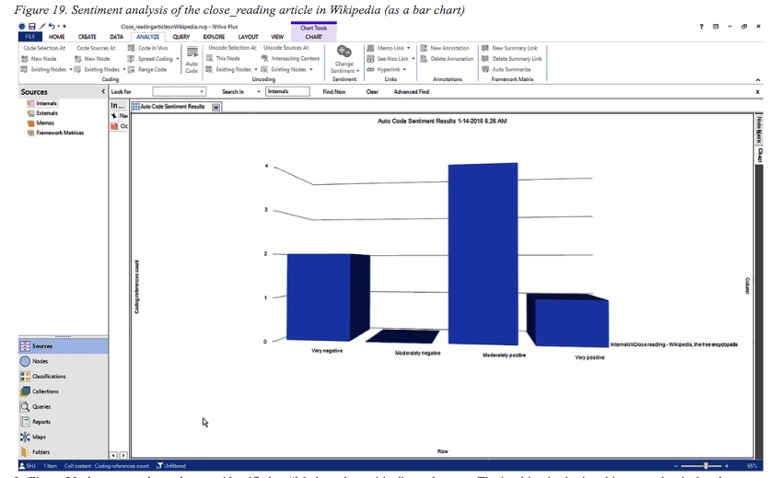

Shalin (2017, p.185-186) showcases the usefulness of NVivo 11 Plus for distant reading. The sentiment analysis tool in NVivo 11 Plus can handle a variety of text data, including large datasets that are difficult to analyze manually. It operates by comparing the text to a sentiment dictionary pre-coded with various degrees of sentiment polarity.

The data for this study comes from Wikipedia articles. The goal is to display the distribution of data points and compare metric values across different subgroups. This demonstrates the sentiment distribution among the readings, which can vary from positive to negative. NVivo 11 Plus™ is the software used for both analysis and visualization.

**5. Clustering**

Clustering is a methodology applied to group objects or data points that exhibit similarity based on their attributes or characteristics. This technique aims to divide a dataset into subsets, also known as clusters, where objects within the same cluster share more similarities compared to those in other clusters. It is important to note that clustering is an unsupervised learning technique. This means it does not require labeled data and operates solely based on the inherent attributes of the data.

Typically, clustering is performed on numerical or categorical data. The objects or data points are clustered together based on their attributes. Various visualization techniques can be applied in the clustering process, such as heatmaps, topic distribution charts, and plotting. As for the algorithms and computing techniques, Latent Dirichlet Allocation (LDA), Non-negative Matrix Factorization (NMF), and K-mean Clustering are commonly used.

**Clustering Visualization - Hierarchy Diagram/ Dendrogram**

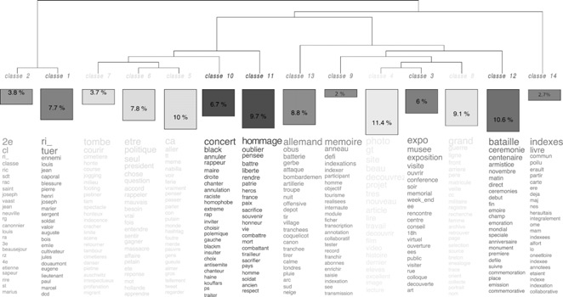

Clavert (2021, p.183-184) employs clustering techniques to analyze over 7.2 million tweets related to the centenary of World War I, collected via Twitter's APIs. This methodology allows for the identification of thematic clusters within the tweets, aiding in the understanding of dominant themes and their evolution over time during WWI centenary commemorations. The data, encompassing tweets from around 1.8 million accounts from April 2014 to December 2018, is visualized through time-series graphs and thematic maps to illustrate the distribution and focus of discussions around the centenary.

The computational aspect of the study involves data collection, pre-processing to normalize and structure the data, and the application of statistical methods based on word co-occurrences to perform clustering. Although the exact clustering algorithm is not specified, the tools mentioned suggest the use of advanced text and network analysis software, possibly including Gephi and IRaMuTeQ. This approach not only highlights the potential of social media data as a historical source but also showcases how digital methodologies can expand and enhance traditional historical research by capturing public engagement and memory in new ways.

**Discussion of the Results and Limitations**

Despite extensive discussions on distant reading and visualization tools, comprehensive research providing an overview of distant reading techniques, including use of corresponding visualization tools is lacking.

Based on our findings, we observe that many papers do not mention the algorithms or computing methods in detail. When data analysis papers fail to provide clear documentation of the algorithms and computing methods used, it raises significant issues related to reproducibility of the research. Reproducibility stands as a fundamental aspect of scientific research, enabling other researchers to validate and build upon previous findings. Without detailed information about the computing methods employed, it becomes challenging for others to replicate the results accurately. Consequently, the validity and reliability of the findings may be called into question, undermining the integrity of the research.

Furthermore, the absence of transparency in methodology gives rise to concerns regarding the credibility and trustworthiness of the research. Readers may question whether the results were obtained using appropriate and robust methods, or if there were potential biases or errors introduced due to undisclosed computing approaches. This lack of transparency erodes confidence in the findings and may hinder the acceptance and adoption of the research within the research community.

Moreover, the validity of the results may be compromised if the computing methods utilized are not suitable for the data analysis tasks at hand. Different algorithms and computing techniques are tailored to specific types of data and research questions. Without proper documentation, it remains unclear whether the chosen methods were the most appropriate for the analysis, casting doubt on the reliability of the results and their interpretation.

**Ongoing Privacy Concerns**

Distant Reading alone will not prevent data leakage, however, unless the algorithms and tools used are privacy preserving. To illustrate the issue, Voyant Tools - a popular web-based platform for text analysis, frequently used by catering to digital humanities scholars, students, and the general public - raises privacy concerns due to its data collection methods. The website discloses that it logs tool usage, settings, and IP addresses, which could monitor user activity. The use of Google Analytics further expands data collection, including IP addresses. Texts submitted to Voyant are stored for later access, leading to concerns about data retention and security. This data might be used for debugging, tool improvement, and research, though in anonymized form. While users can reach out to the project leader with questions, the details about data management and user consent are vague. The lack of explicit consent procedures and security assurances brings up issues regarding user privacy and data safety. To effectively address these issues, a transparent approach, robust security measures, and unambiguous consent procedures are required.

This calls for a solution that combines Distant Reading with Privacy Enhancing Technologies (PETs). Lemieux and Werner (2023) provide a survey of PETs that could be used to assist historians and archivists in processing and analyzing data that contains sensitive personally identifiable information.develop. One suitable technique is would be to use Privacy Preserving Federated Machine Learning - a collaborative learning method wherein multiple parties train a model without centralizing their data or exposing it to other parties (Chen et al, 2021). The first Federated Learning framework was introduced by Google in 2016 to build Machine Learning models using data across multiple devices. Newer approaches to Federated Machine Learning improve upon earlier techniques and provide protection against inadvertent data leakage by machine learning models.The Split Neural Network (SplitNN), for example, involves multiple parties collaboratively training a deep learning model without sharing sensitive raw data. In SplitNN, each party trains a partial deep network up to a specific layer (the cut layer), and only the outputs at this cut layer are shared with a central server, which completes the remaining training. This method ensures that raw data is never exposed to other entities, aligning with the privacy requirements of a project.

In Decentralized Privacy Preserving Federated Machine Learning, for example, multiple computers, often located across different organizations or geographies, collaboratively train a machine learning model while keeping their data on-premise to preserve privacy as in classic Federated Machine Learning, but also require that each computer performs computations on its own dataset and then shares only limited insights, like updated weights or gradients, with other computers (Li et al, 2022). These updates can be shared in a way that protects the privacy of the underlying data, using privacy preserving techniques  to prevent a single computer from revealing too much information or having too much influence over the model.  Decentralized Privacy Preserving Federated Machine Learning also has the advantage of protecting models against attacks on their integrity and single points of failure.

The application of Privacy Enhancing Technologies to help make it safe to apply AI in the analysis of archival holdings is still in its infancy and therefore has many limitations and unknowns, but experimenting with these techniques with may help with a difficult balancing act as archivists juggle AI, privacy and accessibility in archives.

**Bibliography**

Alhudithi, Ella. "Review of voyant tools: See through your text." (2021).

Baker, James. *The Business of Satirical Prints in Late-Georgian England*. Basingstoke: Palgrave Macmillan, 2017.

Ben-David, Anat, Adam Amram, and Ron Bekkerman. "The colors of the national Web: visual data analysis of the historical Yugoslav Web domain." *International Journal on Digital Libraries* 19, no. 1 (2018): 95-106.

​​Chen, K., Zhang, D., Yao, L., Guo, B., Yu, Z., & Liu, Y. (2021). Deep learning for sensor-based human activity recognition: Overview, challenges, and opportunities. ACM Computing Surveys (CSUR), 54(4), 1-40.<https://doi.org/10.1145/3447744>

Clavert, Frédéric. "History in the era of massive data: Online social media as primary sources for historians." Geschichte und Gesellschaft 47, no. 1 (2021): 175-194.

Das, S., Lee, H-P, Forlizzi, J. (2023). Privacy in the Age of AI. *Communications of the ACM*, 66(11).<https://dl.acm.org/doi/10.1145/3625254>

Fasang, Anette Eva, and Tim Futing Liao. "Visualizing sequences in the social sciences: Relative frequency sequence plots." *Sociological Methods & Research* 43, no. 4 (2014): 643-676.

Fjeld, Jessica and Achten, Nele and Hilligoss, Hannah and Nagy, Adam and Srikumar, Madhulika, Principled Artificial Intelligence: Mapping Consensus in Ethical and Rights-Based Approaches to Principles for AI (January 15, 2020). *Berkman Klein Center Research Publication* No. 2020-1.

Graham, Shawn, Damien Huffer, and Jaime Simons. "When TikTok Discovered the Human Remains Trade: A Case Study." *Open Archaeology* 8, no. 1 (2022): 196-219.

Graham, Shawn, Ian Milligan, Scott B. Weingart, and Kim Martin. *Exploring big historical data: the historian’s macroscope*. 2016.

Gu, Zuguang. "Complex heatmap visualization." *Imeta* 1, no. 3 (2022): e43.

Hai-Jew, Shalin. "Applied analytical “Distant reading” using NVivo 11 plus™." In *Social Media Data Extraction and Content Analysis*, pp. 159-201. IGI Global, 2017.

Hendrigan, Holly. "Mixing digital humanities and applied science librarianship: Using voyant tools to reveal word patterns in faculty research." *Issues in Science and Technology Librarianship* 91 (2019).

Joque, Justin. "Visualizing historical web data." *The SAGE Handbook of Web History* (2018): 168-185.

Lemieux, Victoria L., and John Werner. "Protecting Privacy in Digital Records: The Potential of Privacy-Enhancing Technologies." *ACM Journal on Computing and Cultural Heritage* 16, no. 4 (2024): 1-18.

Li, D., Han, D., Weng, T. H., Zheng, Z., Li, H., Liu, H., ... & Li, K. C. (2022). Blockchain for federated learning toward secure distributed machine learning systems: a systemic survey. Soft Computing, 26(9), 4423-4440.<https://doi.org/10.1007/s00500-021-06496-5>

*LibGuides: Systematic Reviews: Snowballing*. (n.d.) <https://libguides.cam.ac.uk/systematic-reviews/snowballing#:~:text=What%20is%20snowballing%3F,your%20inclusion%20criteria%20after%20screening>).

Lü, Linyuan, Tao Zhou, Qian-Ming Zhang, and H. Eugene Stanley. "The H-index of a network node and its relation to degree and coreness." *Nature communications* 7, no. 1 (2016): 10168.

Milligan, Ian. "Mining the ‘Internet Graveyard’: rethinking the historians’ toolkit." *Journal of the Canadian Historical Association* 23, no. 2 (2012): 21-64.

Moretti, Franco. *Distant reading*. Verso Books, 2013.

Pfanzelter, Eva, Sarah Oberbichler, Jani Marjanen, Pierre-Carl Langlais, and Stefan Hechl. "Digital interfaces of historical newspapers: opportunities, restrictions and recommendations." *Journal of Data Mining & Digital Humanities* HistoInformatics (2021).

Royal Society. (2019). Protecting privacy in practice: The current use, development and limits of Privacy Enhancing Technologies in data analysis. <https://royalsociety.org/-/media/policy/projects/privacy-enhancing-technologies/Protecting-privacy-in-practice.pdf>

Therrien, Cristiano S. "Law in the present future: approaching the legal imaginary of smart cities with science (and) fiction." (2021).

Parimala, M., Broumi, S., Prakash, K. *et al.* Bellman–Ford algorithm for solving shortest path problem of a network under picture fuzzy environment. *Complex Intell. Syst.* **7**, 2373–2381 (2021).<https://doi.org/10.1007/s40747-021-00430-w>

Park, Han Woo. "Hyperlink network analysis: A new method for the study of social structure on the web." *Connections* 25, no. 1 (2003): 49-61.